# Basic

1. In HTML create a div with id #target. On button click, Change the background color of '#target' by using JQUERY.
2. In HTML create a div with id #main. On button click, now add html inside of '#target' by using JQUERY.
3. In HTML create a div with id #main and have <span> child inside the div. On button click, Now change the text in the span, a child of '# main’
4. In HTML create 3 divs with class “.info”. On button double click, Change background color of the second '.target'.
5. Have several html tags on the page. Have an input button with id hideElems. When this button is clicked all the elements on the page should be hidden.
6. Have two buttons "HIDE" and "SHOW" and
   * when you click HIDE button, the <ul> elements on the page should be hidden
   * when you click SHOW button, the <ul> elements on the page should be shown
7. Have any number divs inside the <section> tag and then on click of a button, show the number of divs that are inside the section tag. [Show the number of children in alert]
8. Inside the a div “#target”, have h1, h2,h3, h4 and h5 tags. Remove all children of '#target' but not h2.
9. Have a table with 7 rows and 5 columns. [Fill it with any data]. Now on click of a button, make the rows color alternating [Make odd rows to green and even rows to blue].
10. Create 5 check boxes. When you click a button called "Select All" - all the check boxes should be checked. When you click "Deselect All" - all the check boxes should be unchecked.

|  |  |
| --- | --- |
| **BEFORE YOUR CLICK “CHECK ALL”** | **AFTER YOU CLICK** |
|  |  |

1. Have a three select boxes (drop down boxes). When you click on button called VALIDATE then it should check if the select boxes are selected or NOT. If yes, then the TEXT that were selected in each of these select boxes should be added a Div. Create this DIV dynamically.
2. On document ready, turn every second paragraph in a block of text blue, but we want to ignore other elements such as images or divs, etc

# Intermediate

1. Have two buttons - "CHECK URL" and "ADD LINK". The button "ADD LINK" should be disabled by default. Have 5 anchor tags which are linked to your favorite websites. Now on a click of "CHECK URL" button, check to see if "http://www.pro-tekconsulting.com" is included in these 5 anchors tags or not. If NO, then enable "ADD LINK" button. When you click on this "ADD LINK" button, Pro-Tek wesbite link should be added to the DOM.
   * Hint: Use $.each()
2. **FORM VALIDATION:** Have a sign up form like the below one and then validate the form based on addclass/removeclass logic.
   * [SIGN UP FORM EXAMPLE LINK](https://edit.yahoo.com/registration?.src=fpctx&.intl=us&.done=https%3A%2F%2Fwww.yahoo.com%2F&fsredirect=1&fs=LgY.63CHafDRlXmdhv4uhK4jMhG5CmGiZls8BvzkEZFOGp.bOCeP_FZA58r24wdCgerEMNUU)
3. Have two divs side by side - lets call them "Form Div" and "View Div".
   * The first div - "Form Div" should have a simple form with fields - first name, last name, gender, state (select box) and "Save" button.
   * **VALIDATE** the form.
   * The "View Div" should have a button called "EDIT" - but this button should be hidden by default.
   * When you click on the "Save" button, the user entered data should appear in the "View Div" - also the form input fields should be cleared out (should be empty).
   * The View Div should display form data in span tags or p tags or div tags but not as input tags. Also the "EDIT" button should now be visible.
   * When you click on the "EDIT" button, the form should be repopulated with the data so that you can make some changes and save again
4. Make a button (+) in from of “Expand” option and when you click on + it will have a list under it, once the list shows up the (+) will convert to (-) and “Expand” will chage to “Collaspe”. And once you click on (-) the “collapse ” should go back to “Expand” and it will also hide the list and (-) will change to (+)
5. There is a div with id=”main” and it contains a table as follows. Complete the equations. [Hint use eq(), $(this) and $each() ]

#main Div

|  |  |  |  |  |
| --- | --- | --- | --- | --- |
| **num1** | **oper** | **num2** | **equls** | **answer** |
| 42 | + | 12 | = | ? |
| 15 | + | 87 | = | ? |
| 102 | + | 25 | = | ? |

1. There is a div with id=”main” and it contains a table as follows. When you click on the delete button, it should delete the whole row. [Hint use $(this), and jquery DOM methods]

#main Div

|  |  |  |  |  |
| --- | --- | --- | --- | --- |
| **Name** | **Age** | **Loc** | **Zip** | **Action** |
| James | 10 | LA | 90000 | DELETE |
| Peter | 11 | SJ | 90001 | DELETE |
| Kevin | 12 | NJ | 90002 | DELETE |
| Sam | 13 | CH | 90003 | DELETE |

1. Write JQUERY Code. There is a div that contains several input fields (text field, checkboxes, radio,etc). When you click on the checkboxes, show the span that is immediately after checkbox. See the structure for better understanding:

<div id=”myFormDiv”>

<ul>

<li> <input type=”checkbox”/> One <span>this span is hidden </span> </li>

<li> <input type=”checkbox”/> One <span>this span is hidden </span> </li>

<li> <input type=”checkbox”/> One <span>this span is hidden </span> </li>

<li> <input type=”text”/> One <span>this span is hidden </span> </li>

<li> <input type=”text”/> One <span>this span is hidden </span> </li>

<li> <label>One</label> <input type=”radio”/> <span>this span is hidden </span> </li>

<li> <label>Two</label> <input type=”radio”/> <span>this span is hidden </span> </li>

</ul>

</div>

1. Make 3 input fields to enter the phone number. After filling the first three digits in **FIRST FIELLD** the cursor should automatically move on to the second field and when the second field is filled, it should move to the third field

# Advance

1. Have a set of six pictures with previous and next button, buttons should change the images to previous or next image.
2. The structure of the html is like this:

BODY 🡪DIV🡪UL🡪

LI🡪Span🡪 <a href=”resume.pdf”>Download Resume.Pdf</a>

LI🡪Span🡪 <a href=”resume.docx”>Download Resume.docx</a>

LI🡪Span🡪 <a href=”portfolio.pdf”>Download Portfolio.pdf</a>

And so on….

On document load, an appropriate icon should be inserted before the anchor tag text. Download the icons from internet.

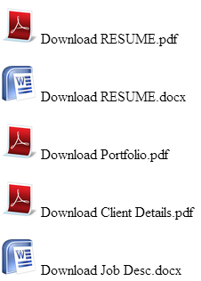

1. **Password Strength Indicator:** Make a input password field, next to it should be a container as shown below:

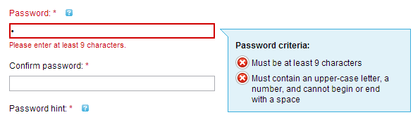

When user enters an uppercase and a number it should make the second criteria to green and should look like this:

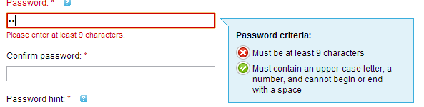

When the user meets both the password criteria then:

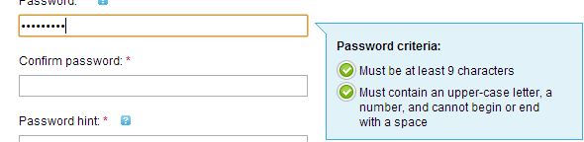

1. Create a JSON file with Customer Information (each customer should have name, age and zipcode) in it. Make AJAX call to get data from a JSON file and display the data in list item like this:

* Kevin is 10 years old and he lives in 90000 zipcode
* Sam is 11 years old and he lives in 90001 zipcode
* Paul is 15 years old and he lives in 90002 zipcode

1. Get data from Remote API ([Rotten Tomatoes](http://developer.rottentomatoes.com/)) and create a nice layout to display Movie Name, Year of release, synopsis, star cast, star rating and Movie Poster.